**Video Game Sales Analysis**

**Dataset Description**

* Rank - Ranking of overall sales
* Name - The games name
* Platform - Platform of the games release (i.e. PC,PS4, etc.)
* Year - Year of the game's release
* Genre - Genre of the game
* Publisher - Publisher of the game
* NA_Sales - Sales in North America (in millions)
* EU_Sales - Sales in Europe (in millions)
* JP_Sales - Sales in Japan (in millions)
* Other_Sales - Sales in the rest of the world (in millions)
* Global_Sales - Total worldwide sales.

**Load Data:**

vg_data = pd.read_csv("C:/Users/chaur/Desktop/Data Analysis/Datasets/vgsales.csv")

vg_data.head()

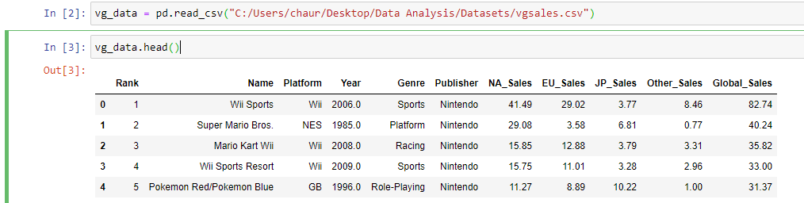

Total rows and columns in dataset:

Dataset contains 16291 rows and 11 columns.

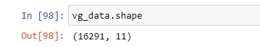

**Summary Statistics for each variable:**

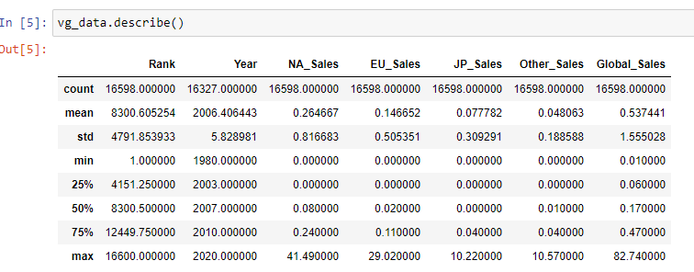

**Top ten Genre with most number of Sales overall:**

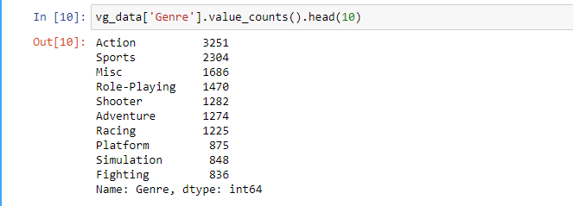

Most of the video games that have been sold worldwide belong to the “Action” genre.

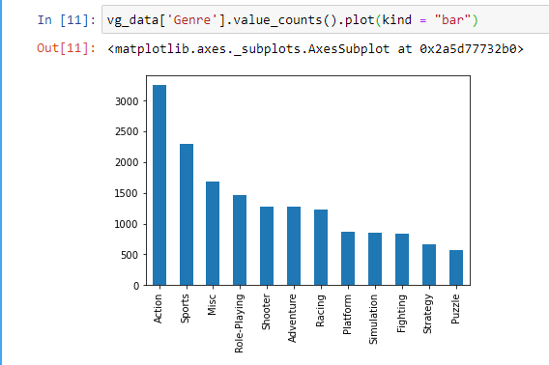

**Top ten Year with most Sales worldwide:**

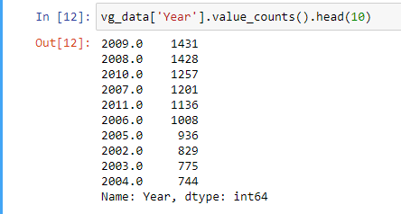

Year 2009 was observed to have maximum sales worldwide

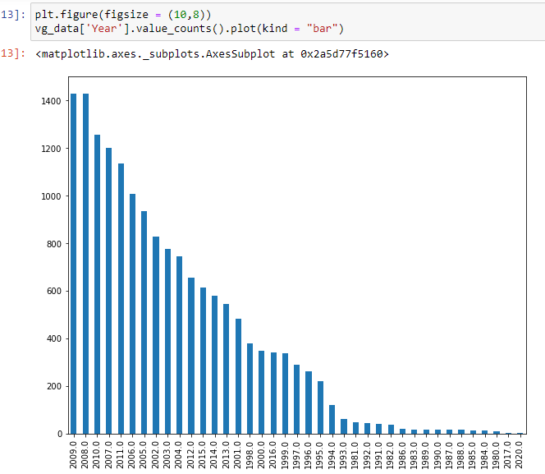

**Top ten Publisher having most number of Sales worldwide:**

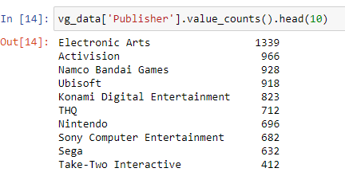

Overall most of the sold video games belong to “Electronic Arts” Publisher.

**Top ten Platform having most number of Sales worldwide:**

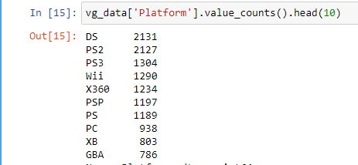

Most of the games sold worldwide belong to “DS” platform

**Top ten Games having most number of Sales worldwide:**

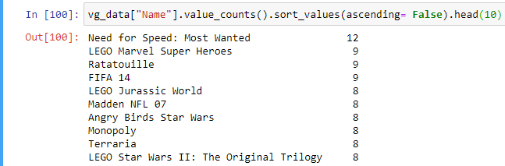

“Need for Speed:Most Wanted” is the topmost game sold worldwide

**Sales in North America**

**Platform with most number of Sales:**

In North America , most games sold belong to “X360” platform

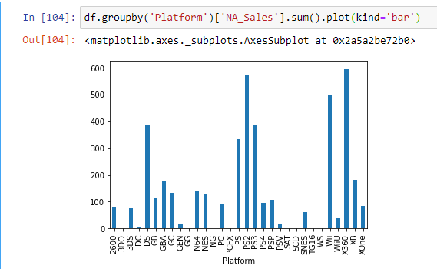

**Top Ten Sales by Publisher**:

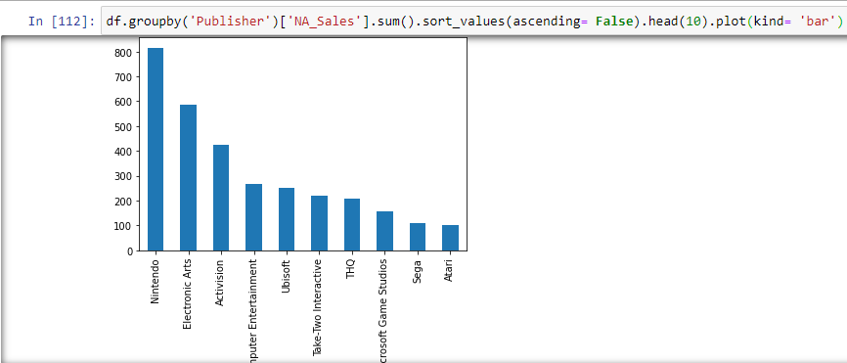

“NIntendo” is the top publisher for video games in North America

**Top Ten Sales by Genre**:

North America Sales mostly comprised of video games from “Action” genre.

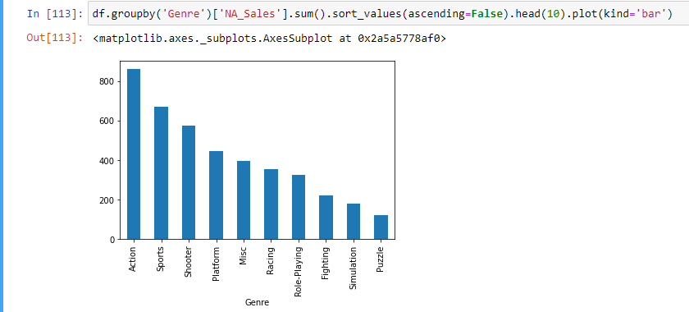

**Top Ten Sales by Name**:

The best selling video game is Wii Sports

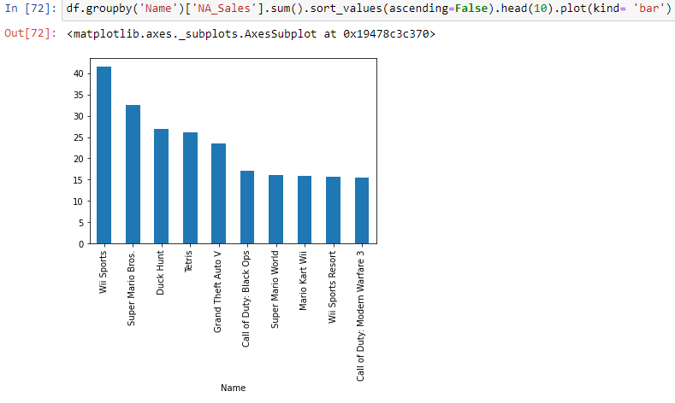

**Top Ten year having maximum sales:**

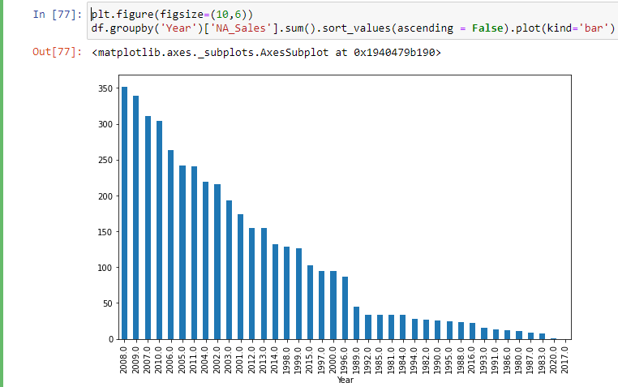

Year 2008 was observed to have most of the video games sales

**Sales in European Union:**

**Top Ten Sales by Name**

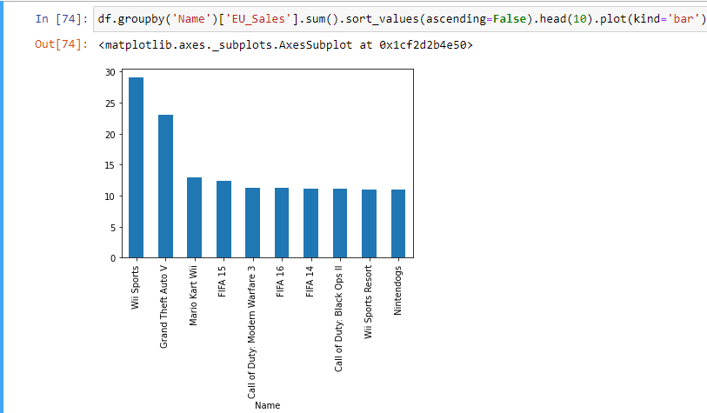

**Top Ten Sales by Genre:**

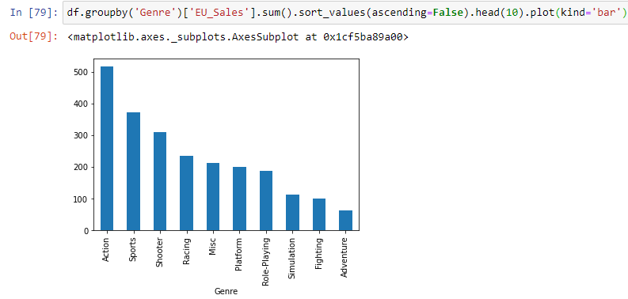

**Top Ten Sales by Platform:**

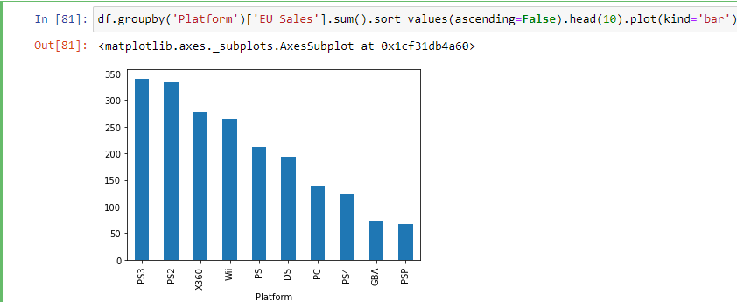

**Top Ten Sales by Publisher:**

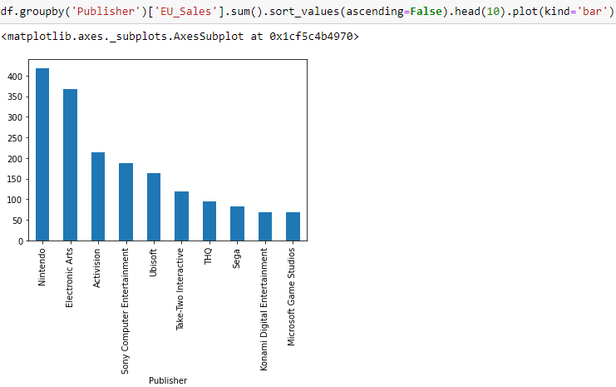

**Top Ten Sales by Year:**

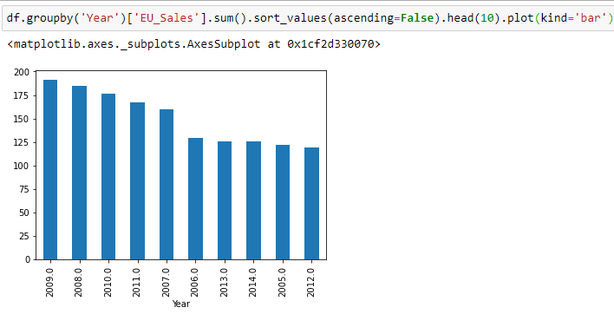

**Sales in Japan :**

**Top Ten Sales by Name:**

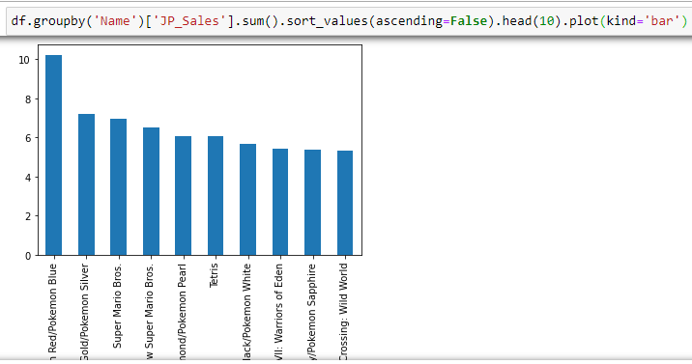

**Top Ten Sales by Genre:**

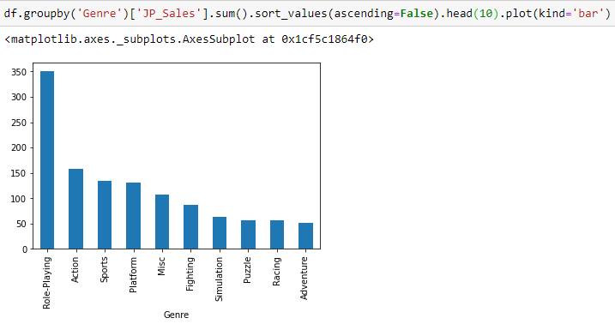

**Top Ten Sales by Platform:**

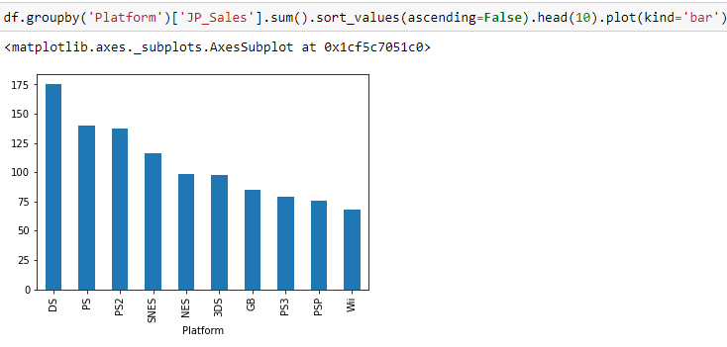

**Top Ten Sales by Publisher:**

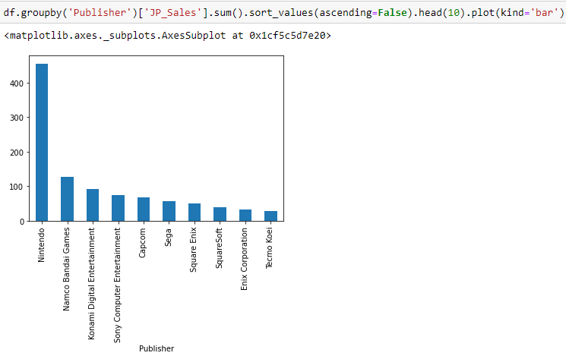

**Top Ten Sales by Year:**

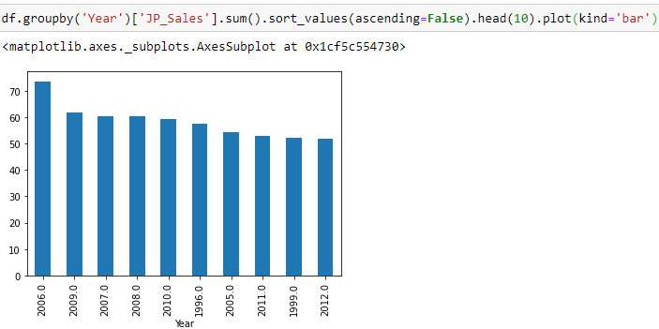

**Sales in Other Countries:**

**Top Ten Sales by Name:**